Module 7 – CSM
- This module will take chats from the Employees (Admins, CSMs, Technicians) as well as registered customers and unregistered customers.
- 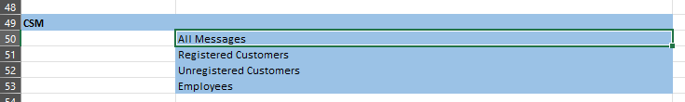
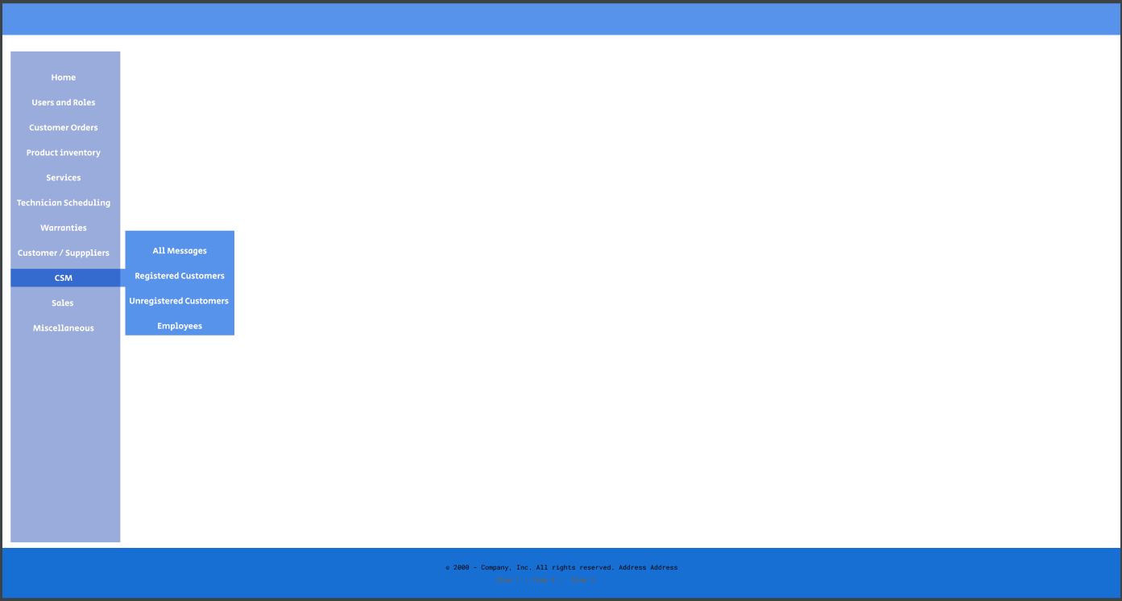

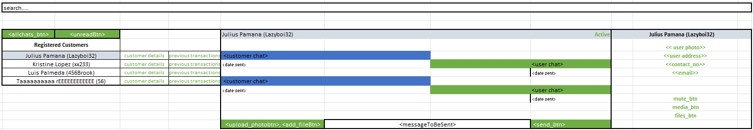
- All chats button will show all registered customer’s chats
- Unread will show all the unread messages
- Media_btn show all media/photos sent. using form
- Files_btn shows all files. using form
- Technicians:
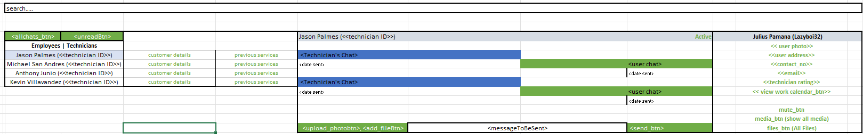
- View_work_calendar_btn will show technicians work calendar (of services) and work schedule (time in and out, dayoff) via form
- Guest_Customers
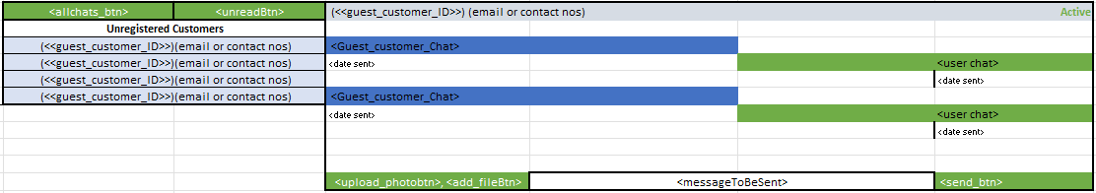

Module 8 - Sales – Add New Sales Invoice
- This will record all customer purchases made in the shop. Recording every shop purchase ensures that the inventory is updated and the transaction is properly logged in the system.
- Get the hard copy of the sales invoice.
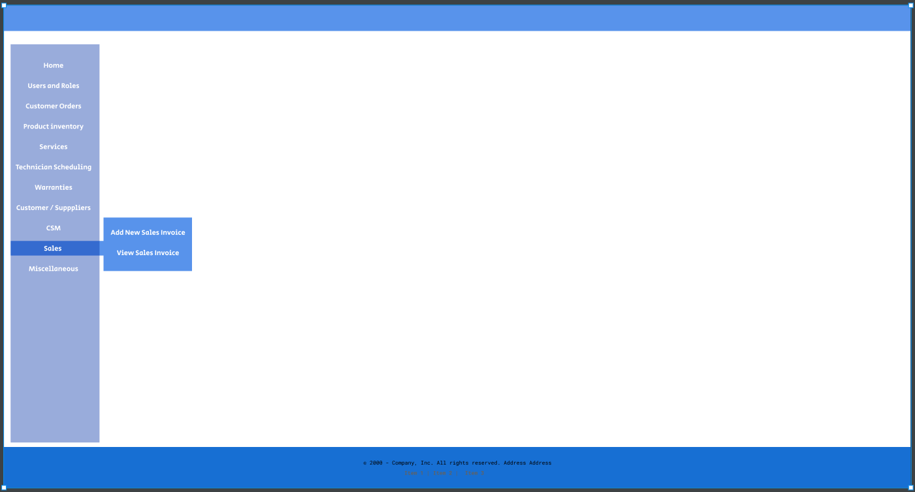
- Click “Add New Sales Invoice”
- A form will show
  - A. Fill all this details.
Invoice Details:
- cus_firstName
- cus_middleName
- cus_Surname
-cus_email
- cus_username (generate default username)
- cus_address
- cus_contact_no
- indiv_items_purchased
- indiv_items_serial
- unit_price_of_each_unit
- total_amount
- payment_method (cash, bank, installment)
Delivery Note
- DeliveryNoteID
- TransactionID
- Delivery Address
* - Street1
* - Street2
* - Barangay (Drop Down)
* - City (Drop Down)
* - Province (Drop Down)
* - Zip/Postal Code (Drop Down)
- Message
5. Click Next. Then a summary will show (Form), a dialog will show asking if all details is correct.
6. Press Save to confirm.
Module 8 - Sales – View Sales Invoice
- This will show the transactions. Both Transactions that was conducted online and online.
- View Transaction button will show the summary of the transaction
  - Customer Details button – summary of customer details (form)
  - View Item Purchased button – list of items purchased, serial, unit price, total (form)
  - View Delivery Note button – summary of delivery note (if for delivery) (form)
  - View Customer Feedback (if online transaction) button – shows feedback (form)
Module 9 – Miscellaneous
- This where the admin can create various new brands, new products etc..
